Municipal Road Crew Turtle Information

We need you!! All Ontario turtles are in decline, and a major threat affecting them is fatal vehicle collisions on roads.

As road crew personnel you have the power to help turtles in danger on and along roads while at work.

Here is how you can help:

1. Move turtles off the road

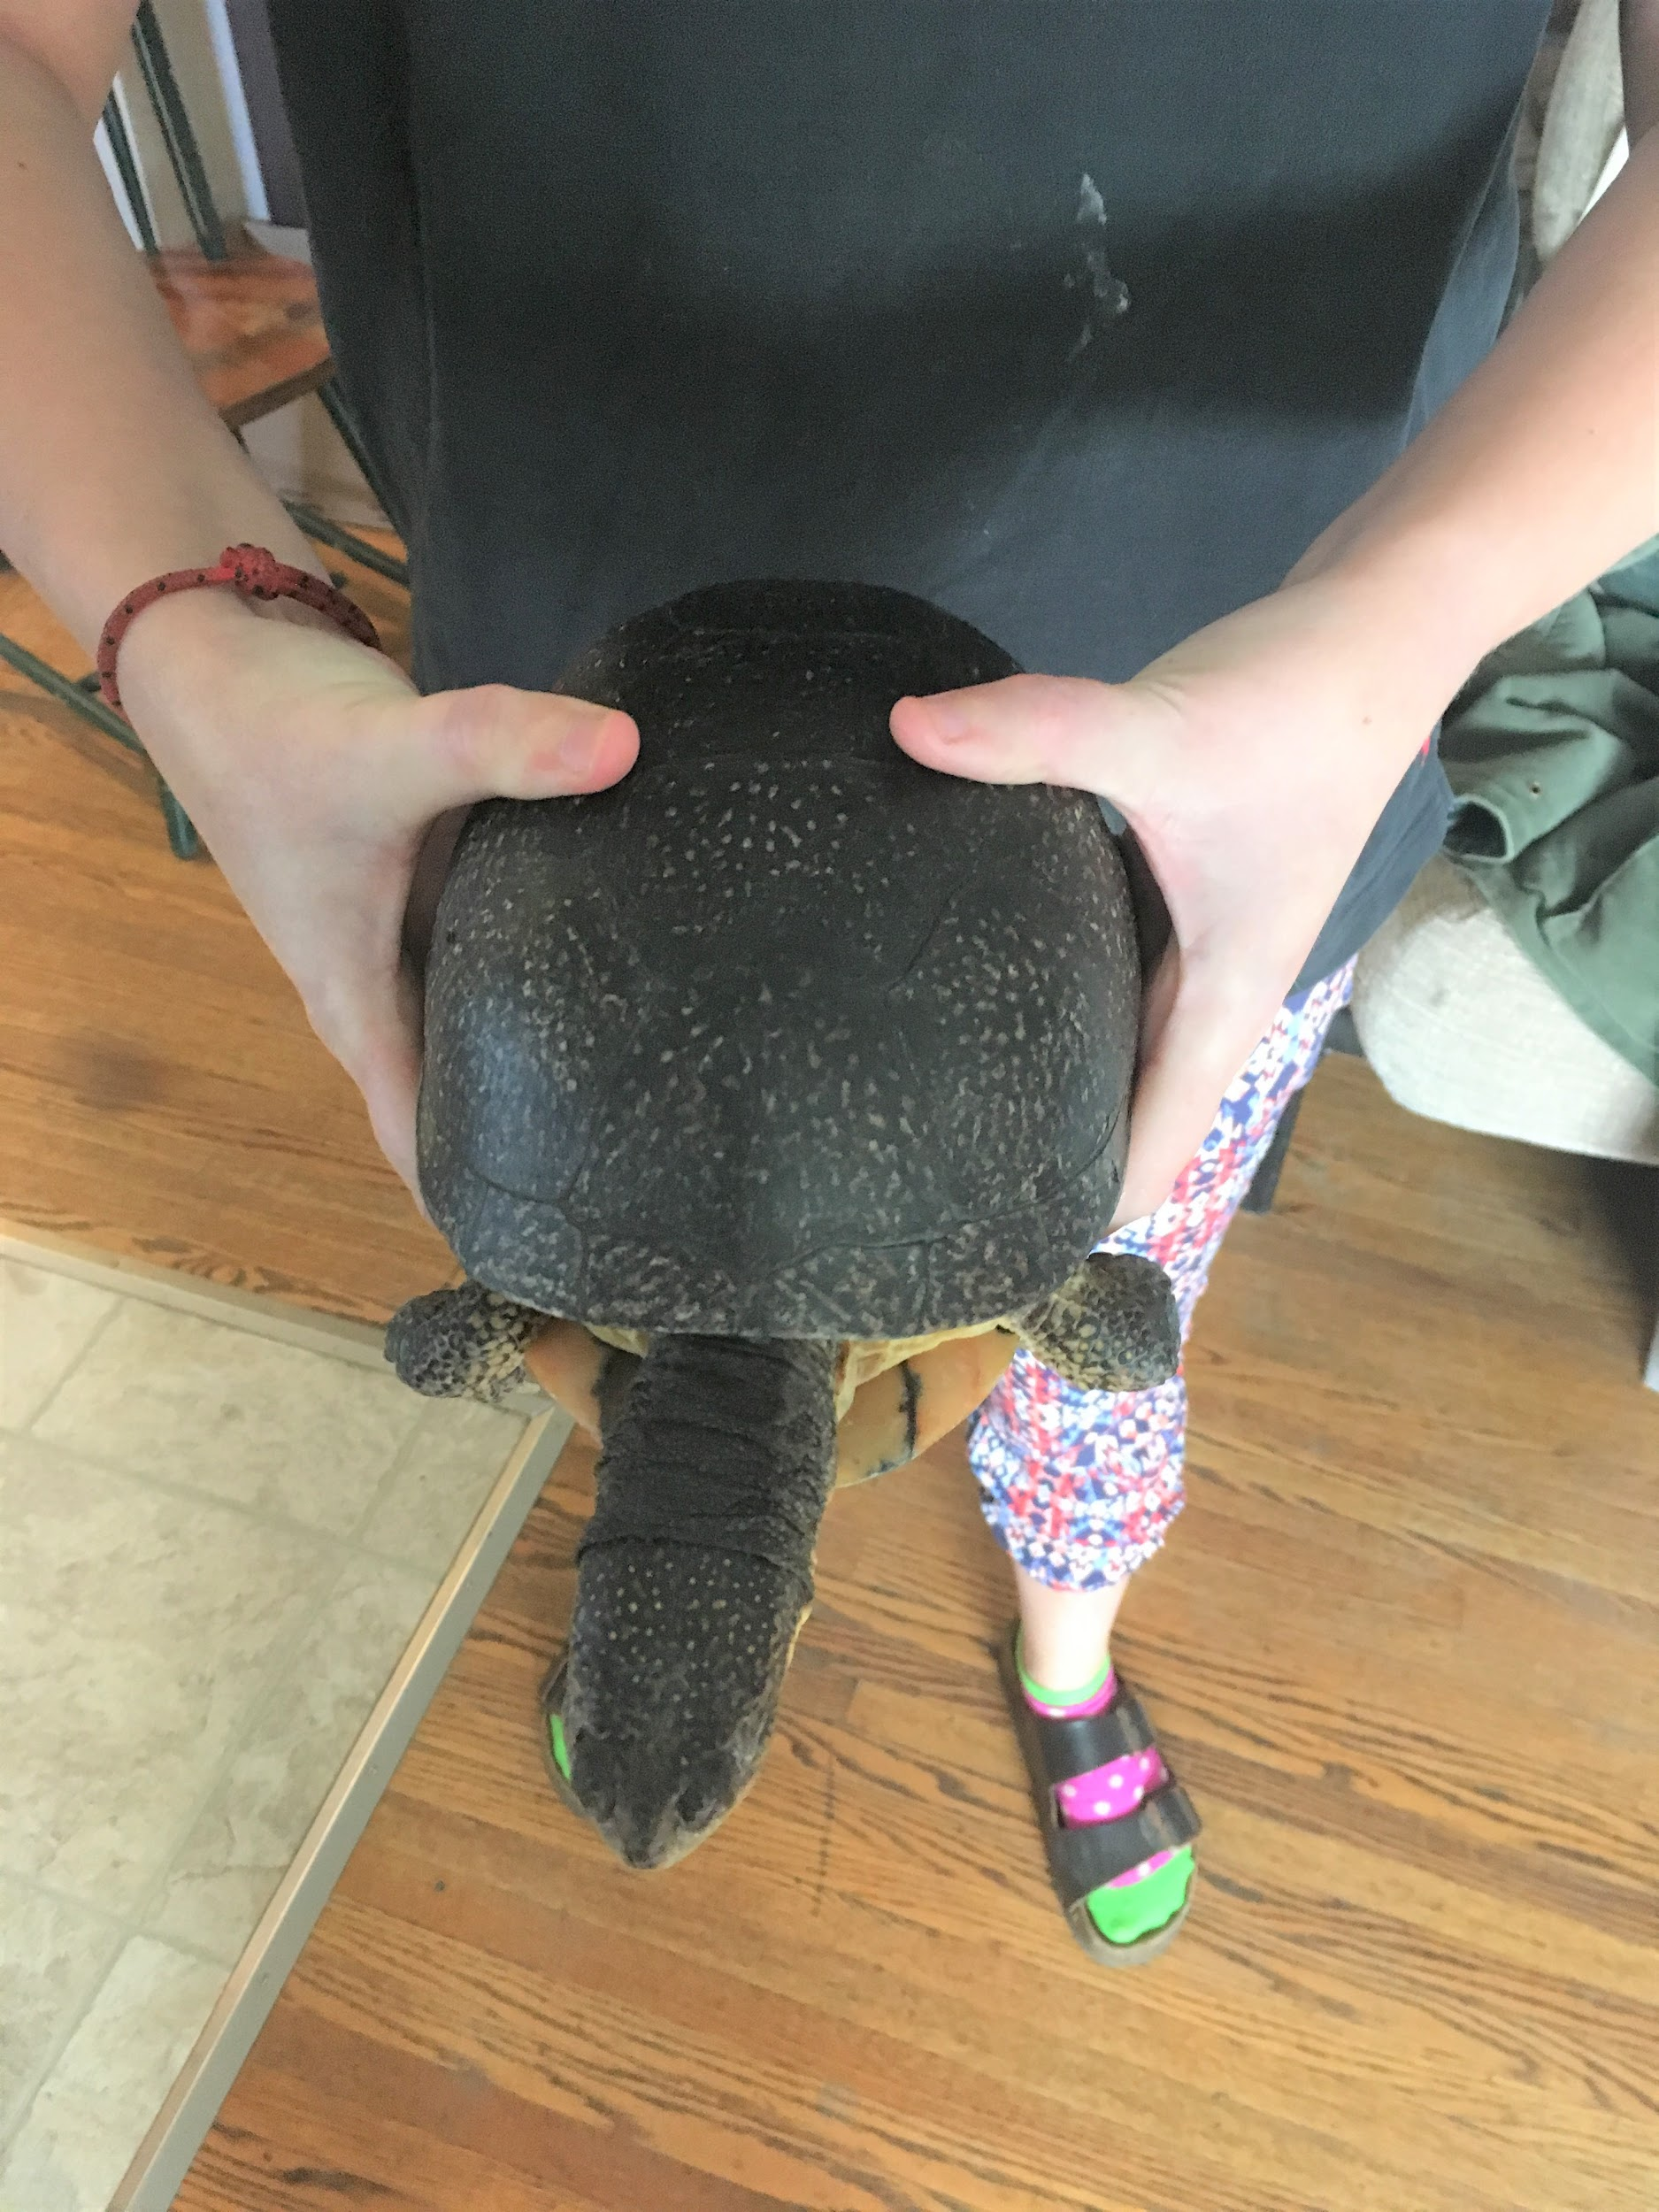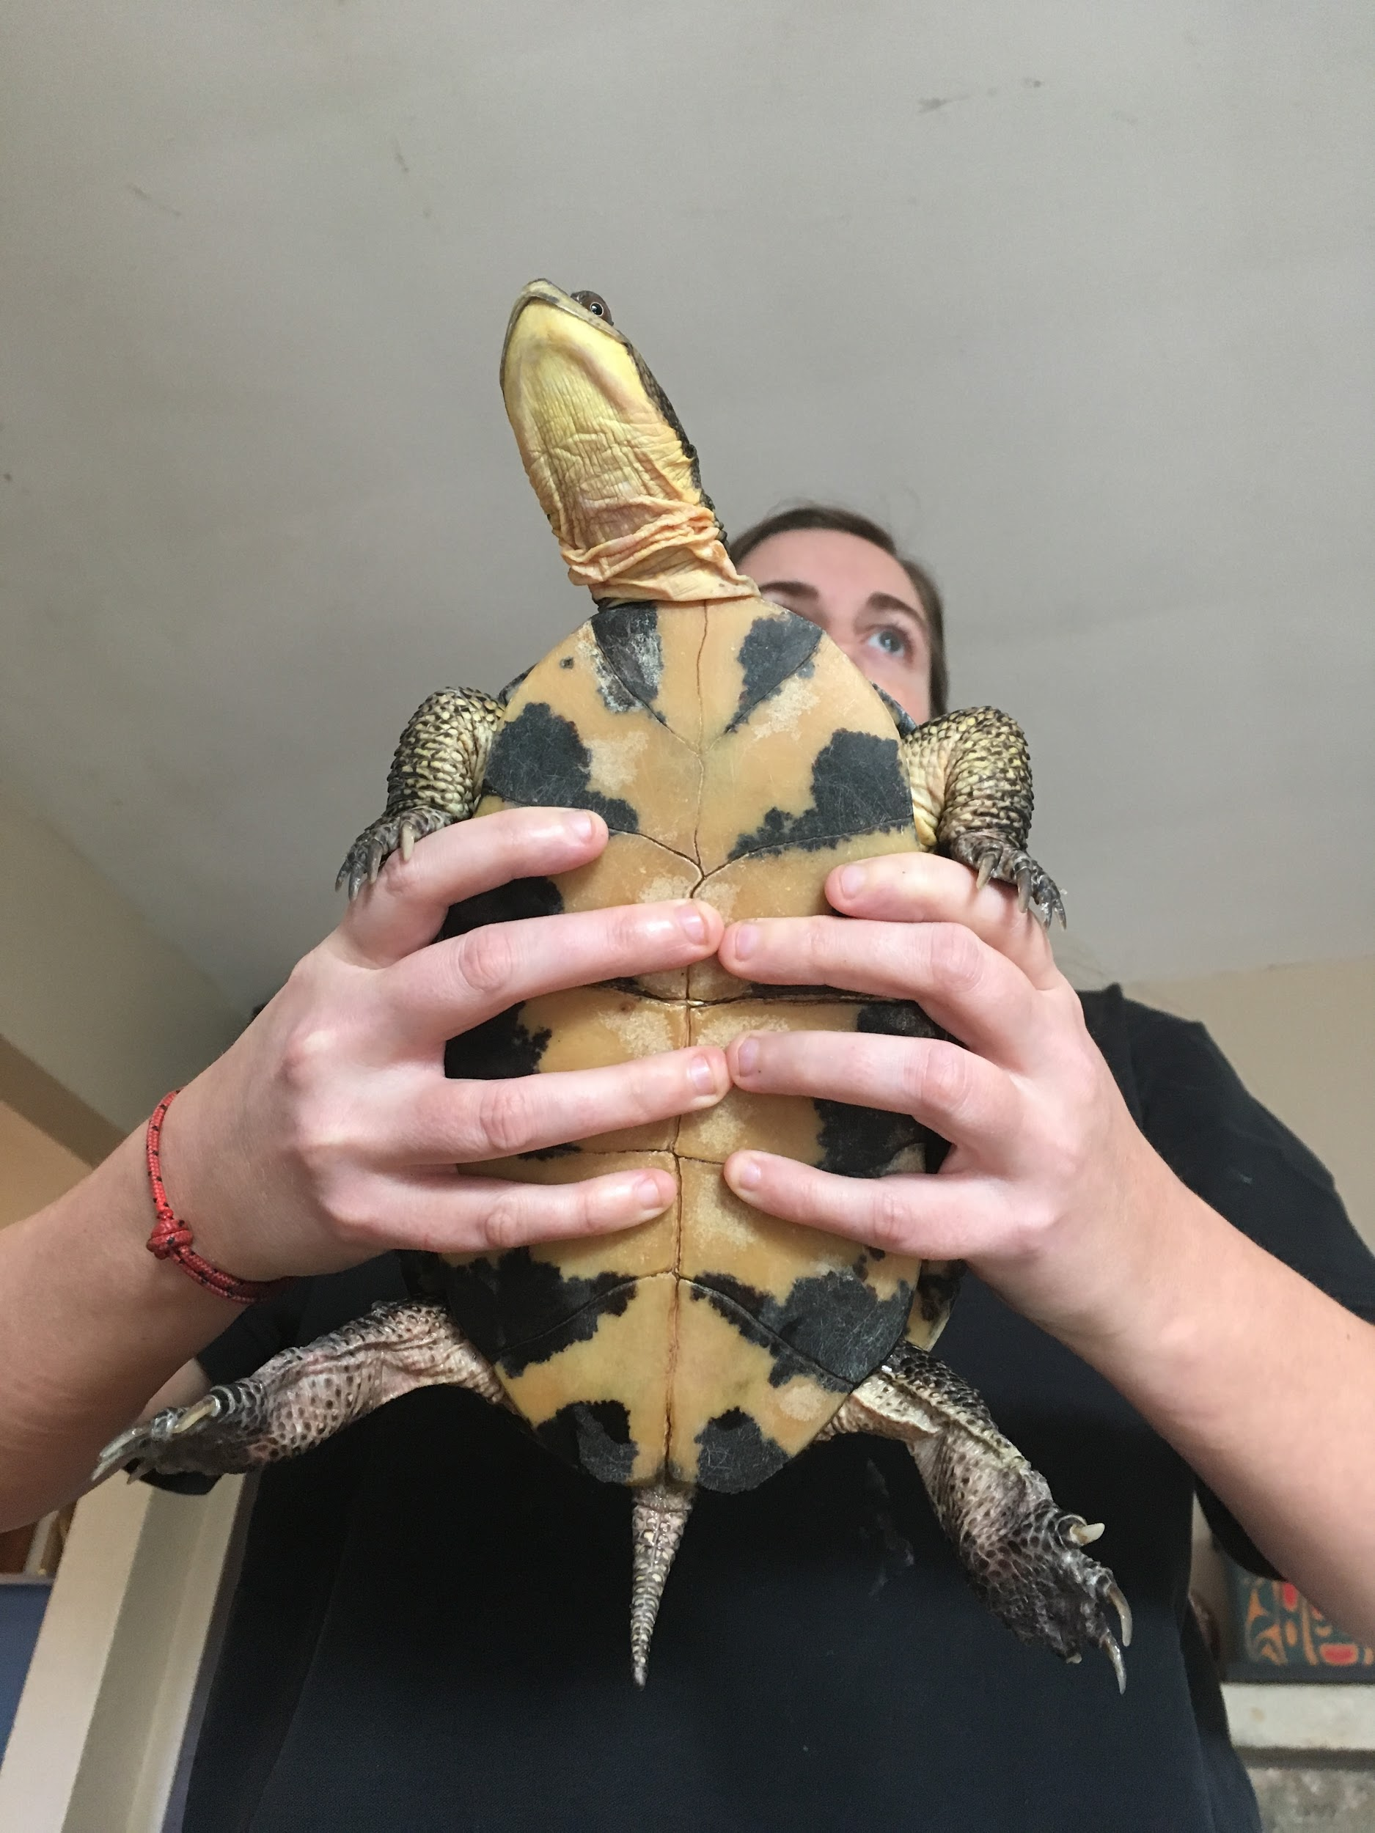
- Always move turtles off the road in the direction they were travelling/ facing, if not they will just cross the road again to get where they were originally travelling.
- To help Snapping Turtles, carry them by gripping the back of their shell sticking your fingers in the squishy part under the shell above the back legs. If you can not lift them up all the way because they are too heavy, lift just their back legs and help them walk forward with their front legs (“the wheel barrow”).
- To help other turtles, grip them firmly like you would a hamburger with your palms tight against their shell. Angle their belly shell away from you in case they pee.

2. Call the S.T.A.R.T (Saving Turtles At Risk Today) hotline 705 955 4284 for:
- Injured turtles
- Nesting turtles (a nesting turtle will be laying in the ground with a disturbed pile of dirt behind her, and she may be rocking side to side slowly)
- Blanding’s Turtles and Spotted Turtles (these species are especially at risk)
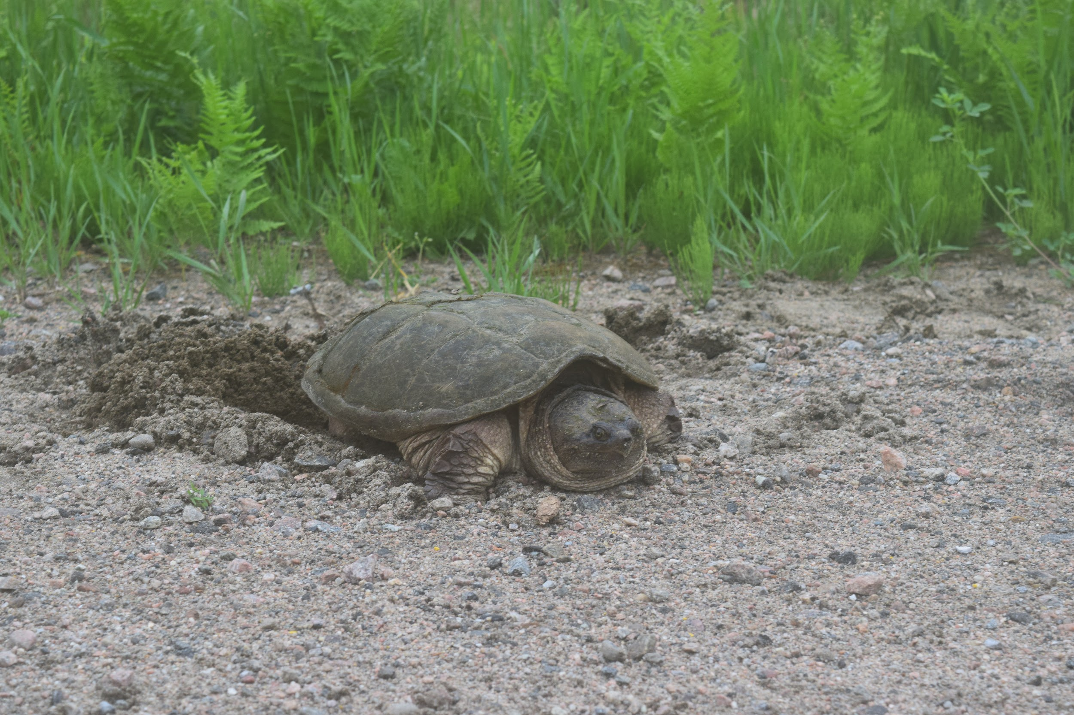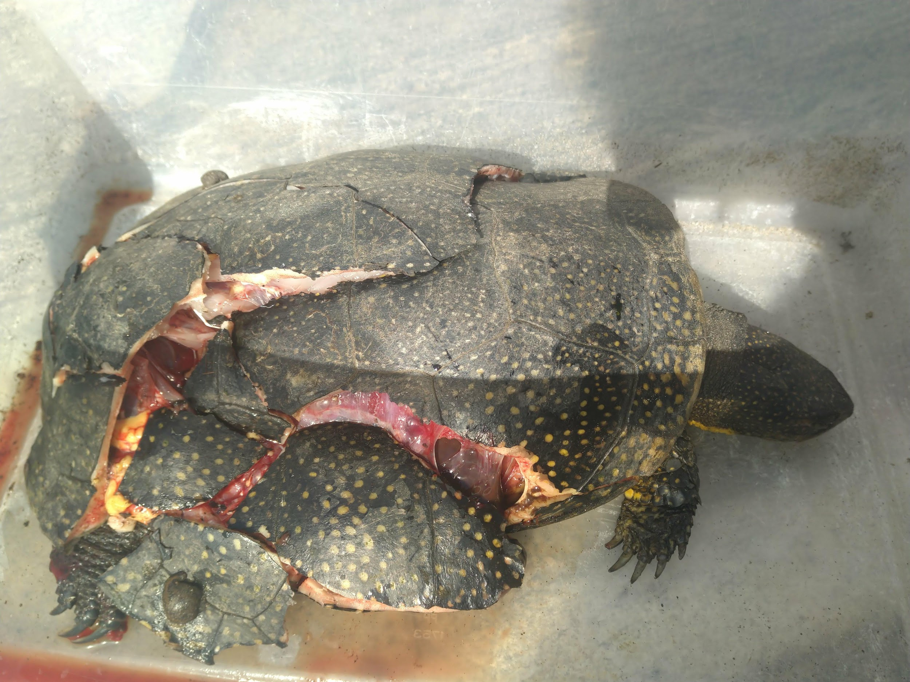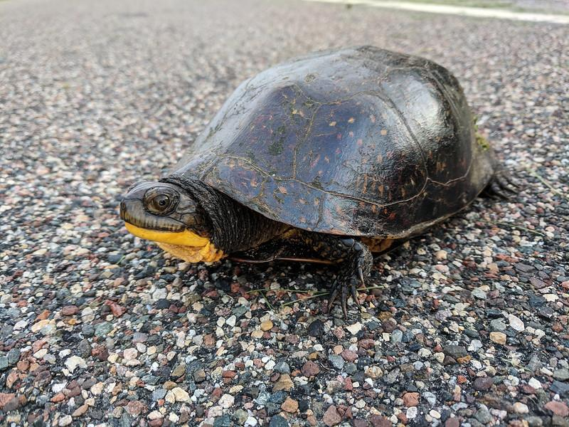

3. Use the Turtle Guardians App to report turtles you see
- This app has pictures and helpful tips for identifying any turtle you could find in Ontario
- By reporting the turtles you see on this app, you will provide conservation agencies with valuable information about where species are so that we can take steps to protect them and their habitat

