Methodology for Mapping Human Impact.
Research Summary

The Human Footprint and the The Last of the Wild:
ERIC W. SANDERSON, MALANDING JAITEH, MARC A. LEVY, KENT H. REDFORD,
ANTOINETTE V. WANNEBO, AND GILLIAN WOOLMER.

INPUTS
Monitor changes in land development-- Historical land use land cover datasets, aerial photography, satellite imagery etc would be very useful.
- Development of resource based activities
- Development of tourism companies in the areas
- New communities
- New named places (could indicate more people or more regular travel in the area?)
- Road building-- can assess the presence 0r pervasiveness of invasive species, connectivity, fragmentation, level of human activity etc. Differentiate between the different road types?
- Trail infrastructure?
- Population statistics, population density new populated areas
- Built up areas and NIMA dataset?
- Monitor size and “remoteness” of areas, and how those areas are being disturbed.
- Electrical power infrastructure
- Size of parks/ conservation areas and how many people living within 50km of it? ( high density and small parks lead to higher extinction rates)
- # of hunting/ trapping licenses in the area by species. # of total hunted per year over time.
- Changes in hydrology
Potential Datasets and categories
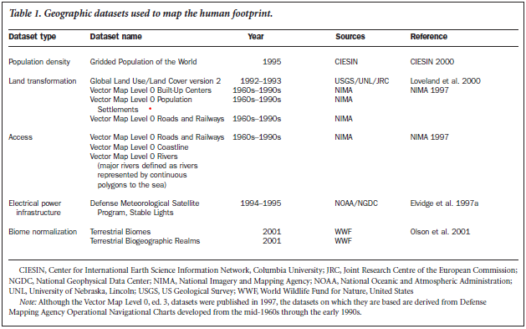

Methodology
- A consistent map projection with a CONSISTENT set of boundaries/ borders
- A grid system (1km x 1km?)
- Code each dataset- would we need to do a separate on for every taxa? Then summarise the impact for a final priority score, (0-10 or 0-20?)
- How can we determine the effect of population density and effect on the habitat modification for each taxa?
- “In this study,we used a continuum approach, in Which human influence scores for densities between 0 and 10 persons per km2 increased linearly from 0 to 10 and the score above 10 persons per km2 was held constant at 10”
- Consider a habitat fragmentation index?
- Built Up index: Maximum score of 10 to built up environments. 6, 7, 8 to agriculture (depending on level of input), 4 to mixed use land cover, 0 to all other land cover (considered natural)
- Roads:
  - 2km buffer around roads-- is this reasonable for all species? Can we customize based on taxa. Score of 8 for human impact. It is likely that this is an overestimation.
  - Other access- humans walking in the landscape. How far can people get. Is this important? 2-15km away from a road have a value of 4 indicating a modest influence with intermittent use.
- Hydrology
  - (MAJOR rivers and lakes that could support human tranportation ( how much of an affect does a canoer have on the landscape or behaviours of the species of interest? How many poeple would have to be in the area for there to be an effect?
  - dams?
- Shoreline NATURAL vs NOT
- Light pollution ( a proxy for population distribution)
  - 10 for areas with lights visible more than 89% of nights
  - 8 to areas with lights visible 40-88%
  - 4 to areas with lights visible less than 40%
  - 0 for areas where no lights are visible.
  - What is the buffer area for that?
  - Does forest density or distance away have an effect? -- maybe consider doing a viewshed analysis around areas with lights?

INDICATORS OF WILDNESS
Aplet G, Thomson J,Wilbert M. 2000. Indicators of wildness: Using attributes
of the land to assess the context of wilderness. In Cole DN,McCool
SF, eds. Proceedings: Wilderness Science in a Time of Change. Ogden
(UT): USDA Forest Service, Rocky Mountain Research Station. Proc.
RMRS-P-15
- Wilderness definition? We are probably going to come up with a definition of our own
- Remoteness
  - Free from influence of mechanical sight, sound, and smell. (human or animal?)
- Uncontroleld Processes
  - Fire suppression, dams, extermination, pesticides, herbicies agriculture, plantation etc?
  - Watershed integrity
  - Altered fire regimes
- Natural composition
  - Invasive specoes
  - Plantations
  - Changes in prey migrations
  - Raods, settlements, power transportation hugely affect the wilderness aspect. “Trails and temporary shelters, features such as were common long before the advent of the white race, are entirely permissible”
- pollution is one of the best studied and best documented of the indicators of wildness.
  - Aquatic and terrestrial nutrient and chemical composition?
  - Light pollution
- Methodology
  - Raster based approach indicating the presence or absence of limiting factors within a cell. 1km ^2
  - GRID Module

Human Population Density and the Future of Biological Diversity
Cincotta RP, Engelman R. 2000.Nature’s Place:Human Population Density
and the Future of Biological Diversity.Washington (DC): Population Action
International.

A Global Analysis of the Impact of Human Concentration on Species Fragility
Ram Pandit Dr. David N. Laband School of Forestry and Wildlife Sciences Auburn University
- Population density and specifically household size or dwelling size.
  - A population in a sprawled environment has more negative impacts than than a population that is more dense, living in a smaller area or fewer built structures.
- GINI coefficient to identify sprawl (instead of wealth distribution)
- 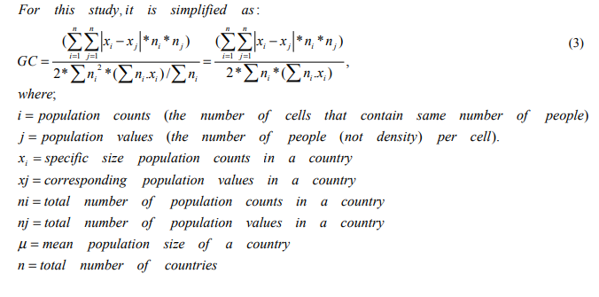

Further Reading:
- Estimating population density by light pollution.?

